Forecasting Rainfall in KP and Balochistan
Monthly Rainfall, 1981–2025: SARIMA vs LSTM and Other Models
Dataset 4 (Kaggle: Citywise Pakistan Rainfall) · Shahan Anwar, MS Artificial Intelligence

1. Dataset Description
Item | Details
Source | Kaggle: “Citywise Pakistan Rainfall by QTR (1981–2025)”, based on CHIRPS satellite + station rainfall (the same rainfall source as Paper 7)
Size | 56,176 rows: rainfall in mm for every 10-day period, for each province, from Jan 1981 to Jul 2025
Main columns | Date, province code, rainfall (mm), province, year, month
Cleaning | One junk row removed. KP has two readings per date, so we took their average. 10-day values were added into 535 monthly totals.
Note | It has only rainfall: no temperature, humidity, soil, height or river data.

Simple words: Think of a rain diary: for every 10 days since 1981 it writes how many millimetres of rain fell in KP and in Balochistan. We add the days up into months.
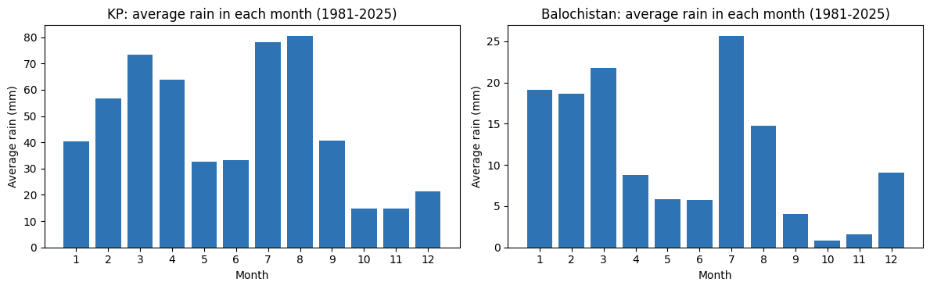
Figure 1: Average rain in each month, 1981–2025
Region | Average month | Wettest month ever | Wettest season
KP | 46.0 mm | 161 mm (Aug 2010) | Mar–Apr and Jul–Aug
Balochistan | 11.4 mm | 118 mm (Jul 2022) | Jul, then Jan–Mar

Observation: KP is much wetter than Balochistan (about 4 times). KP has two rainy seasons (spring and monsoon). Balochistan is mostly dry, but July (monsoon) is its wettest month. Both regions have a clear yearly pattern, so a “normal for that month” guess is already a good guess.

2. Problem Definition
Question: “Using the rain up to this month, how much rain will fall next month in KP and Balochistan?”
- This is the same task as Paper 9 (rainfall forecasting with LSTM vs SARIMA), but for the two provinces of my thesis.
Simple words: This predicts how much rain, as a number. It is not a yes/no flood alarm, so we use error scores instead of a confusion matrix.

3. Experimental Setup and Models
- Study (training): 1981–2014 (396 months). Exam (testing): 2015 to July 2025 (126 months). The models never saw the test years.
- Inputs: rain this month, 1, 2 and 11 months ago, and the month of the year.

Model | Simple explanation
Climatology | “Next month will have the normal rain of that calendar month.” The simple benchmark.
Same as this month | Next month = this month. Easy but unrealistic for rain.
Linear Regression | Draws one straight-line rule from the inputs to the answer.
Random Forest | 300 decision trees; the average of their answers.
XGBoost | Trees built one after another; each fixes the earlier mistakes.
SARIMA | A classic statistics model made for repeating yearly patterns (seasons).
LSTM | A neural network that reads the last 12 months in order, like reading a story.

4. Evaluation Metrics
Metric | Meaning in simple words | Better is
R² | How much of the up-and-down of rain the model explains. 1 = perfect, 0 = no better than always guessing the average, below 0 = worse than that. | Higher
MAE | Average miss in mm. MAE 18 means the guess is wrong by 18 mm on average. | Lower
RMSE | Like MAE but punishes big misses more. | Lower

5. Model Results
KP | R² | RMSE (mm) | MAE (mm)
Climatology (normal) | 0.475 | 25.2 | 19.2
Same as this month | -0.357 | 40.5 | 30.3
Linear Regression | 0.272 | 29.7 | 22.8
Random Forest | 0.423 | 26.4 | 19.4
XGBoost | 0.371 | 27.6 | 20.4
SARIMA | 0.520 | 24.1 | 18.3
LSTM | 0.271 | 29.7 | 22.3

Balochistan | R² | RMSE (mm) | MAE (mm)
Climatology (normal) | 0.293 | 14.0 | 7.7
Same as this month | -0.579 | 20.9 | 13.3
Linear Regression | 0.067 | 16.1 | 10.1
Random Forest | 0.290 | 14.0 | 8.2
XGBoost | 0.256 | 14.4 | 8.5
SARIMA | 0.343 | 13.5 | 7.6
LSTM | 0.102 | 15.8 | 9.2

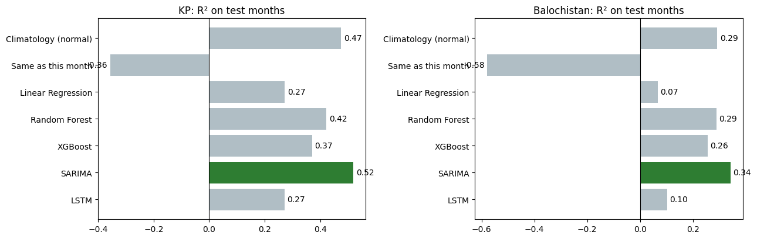
Figure 2: R² of each model (green = best)
Observation: SARIMA is the best model in both regions (R² 0.52 in KP and 0.34 in Balochistan), and LSTM is clearly weaker (0.27 and 0.10). But SARIMA beats the simple “normal for that month” guess only by a little (0.52 vs 0.47 and 0.34 vs 0.29). “Same as this month” is worse than the average (negative R²), so rain this month says little about rain next month.

6. Real Rain vs Predicted Rain
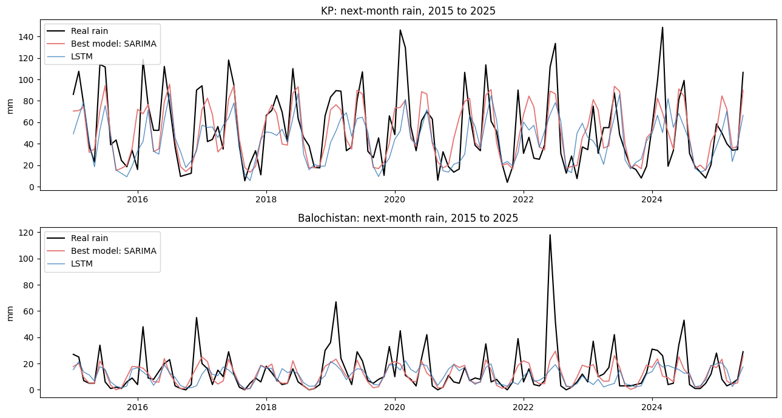
Figure 3: Real next-month rain (black) vs SARIMA (red) and LSTM (blue), 2015–2025
Observation: The red and blue lines follow the yearly up-and-down shape well, but they stay in the middle and do not reach the tallest peaks. The biggest example is Balochistan in mid-2022: real rain was far above everything seen before, but the models stayed low.

Region | Wet month | Real rain | Normal | Best model
KP | Apr 2024 | 148.5 mm | 60.9 mm | 68.7 mm
KP | Mar 2020 | 146.0 mm | 68.2 mm | 73.9 mm
KP | Aug 2022 | 133.5 mm | 79.0 mm | 86.5 mm
Balochistan | Jul 2022 | 118.0 mm | 21.9 mm | 22.7 mm
Balochistan | Mar 2019 | 67.0 mm | 19.2 mm | 23.4 mm
Balochistan | Aug 2022 | 52.0 mm | 12.7 mm | 29.4 mm

Observation: In the very wet months the models predicted only 1.1 to 1.3 times the normal rain, while the real rain was 2 to 5 times the normal. Balochistan July 2022 (the year of the big Pakistan floods) was 118 mm, but the best model said 22.7 mm. In the monsoon months (Jul–Sep) the scores drop further: SARIMA R² is 0.48 in KP and 0.22 in Balochistan, and LSTM is below zero.

7. Limitations
- Only rainfall history, no weather, soil, terrain or satellite images.
- Monthly totals for a whole province hide local storms. A flash flood can come from a few hours of rain in one valley.
- The data ends in July 2025 and has only 126 test months.

8. Conclusion and Link to My Thesis
- We used 45 years of rainfall (1981–2025) to forecast next month’s rain in KP and Balochistan.
- SARIMA beat LSTM (as a seasonal pattern model should), but only slightly beat the “normal for that month” guess. Models that see only past rain learn the seasons, not the surprises.
- The extreme rainfall that causes floods (for example, Balochistan July 2022) was missed by every model.
- So rainfall history alone cannot warn of a flash flood. My thesis needs short-term satellite rainfall (GPM IMERG), weather and terrain data to warn hours ahead in KP and Balochistan.

